Crystal chemistry

Did you know?
About a girl's best friend – diamonds
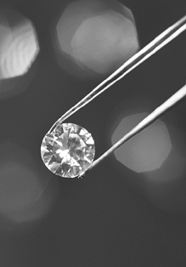
Diamonds, a crystalline form of the chemical element carbon, are the most romantic of crystals, given as symbols of love and permanence.
They were first discovered around 800 BC in riverbeds in India. One of the world's richest sources of diamonds is South Africa, where they are mined from rock called 'Kimberlite pipe', named after the town Kimberley. Other countries rich in diamonds are Australia, Botswana, Zaire and the former Soviet Union. Diamonds formed in volcanic magma about 170 miles below the Earth's surface, solidifying as the magma moved upwards and cooled. This took a long time
Diamond
The Cullinan diamond, with a mass of 621.2 g, was the largest diamond ever found, mined in 1895. This was a bit big for one engagement ring, so it was decided to cut the diamond into smaller pieces. The diamond cutter spent months deciding how to go about the task, and apparently fainted with shock after first splitting the stone in two. He recovered, and finally nine large and 96 smaller diamonds were produced. The most famous large diamond, called 'Cullinan I' or the 'Star of Africa' is in the Royal Sceptre and can be seen on a visit to the Crown Jewels in the Tower of London.

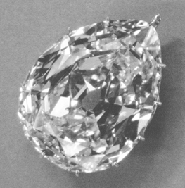
The Cullinan 1
Crown © / The Royal Collection © 2004,
Her Majesty Queen Elizabeth II.

Diamond is the hardest known substance, so can only be cut with a diamond-edged saw! Diamond mass is measured in 'carats'. One carat is equal to 0.2 g. Work out how many carats the original Cullinan diamond was – and compare that with those you see next time you walk past a jeweller's window!
Questions
1. How do large diamonds form?
2. Why are large diamonds rare?


